250 rpm Synchronous Motor 9904 111 31813

The 31813 series low speed synchronous motor is a development of the standard industrial series specifically designed for use in high quality record decks that utilise the belt drive principle.
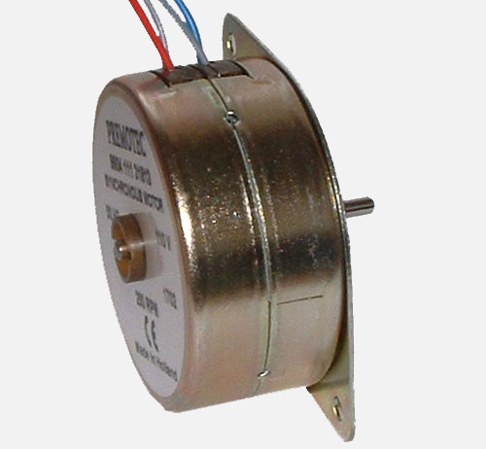
Particular attention has been given to the magnetisation of the 24 pole rotor to optimise smooth running. This, together with the high accuracy of stator pole placement minimises torque ripple and provides low audible noise.
The motor which is designed for mounting horizontally with output shaft vertically up is provided with an increased shaft length and a 3 mm diameter to aid the fitting of the drive pulley. When fitting the drive pulley the shaft rear end should be supported to ensure that the axial load limitation is not exceeded.

The windings have been specifically designed to facilitate dual voltage operation, a 6.8K Ohm resistor being used in series when operation from a 220 Vac supply is required.

Dimensions mm.

Specification

Nominal Voltage | Vac | 110 | Max Working temperature | deg. C | 105
Permissible voltage fluctuation | % | -15 / +10 | Ambient temperature range | deg. C | -5 to +70
Supply Frequency | Hz | 50 | Torque derating | %/ ^{O}C | 0.25
Speed @ 50 Hz | rpm | 250 | Insulation according to CEE10 |  | Class 2
Direction of rotation |  | reversible | Insulation test voltage | V | 2500
Direction control capacitor | μ F | 0.22 ( 250 Vac ) | Maximum radial force | N | 5
Input Power | W | 1.8 | Maximum axial force | N | 1.5
Input current | mA | 18 | Mass | g | 16
Housing |  | zinc plated | Bearings |  | slide

Connections


Mclennan Servo Supplies Ltd. Tel: +44 (0)8707 700 700 www.mclennan.co.uk

